
Making a complaint.

At Bspoke Sports & Leisure, we care about our customers and believe in building long-term relationships by providing quality products combined with a high standard of service. If you have cause for complaint, either in relation to your policy or any aspect regarding the standard of our service, please see the contacts outlined below.

As you have arranged your policy with Bspoke Sports & Leisure through a Broker or Intermediary, you should firstly direct your complaint to the Broker or Intermediary with whom you arranged your policy.

Useful complaint contacts are provided below:

Reason for complaint | Contact | Contact Details
Sales or Service  Related | Complaints Department  Bspoke Sports & Leisure | Brookfield Court  Selby Road  Leeds  West Yorkshire  LS25 1NB  complaints@bspokesportsleisure.co.uk  0113 345 1768
Claims (other than Legal Expenses claims noted below) | Complaints Department  CPAdjusting Limited | Queen Charlotte House  53-55 Queen Charlotte Street  BS1 4HQ  complaints@cpadjusting.com  0117 9299 255
Legal Expenses Claims | Complaints Department Arc Legal  Assistance Limited | PO Box 8921 Colchester  CO4 5NE  customerservice@arclegal.co.uk  01206 615000

Bspoke Sports & Leisure Complaints Process

Making a complaint can be stressful, that’s why we want to make the whole process as easy as possible for you.

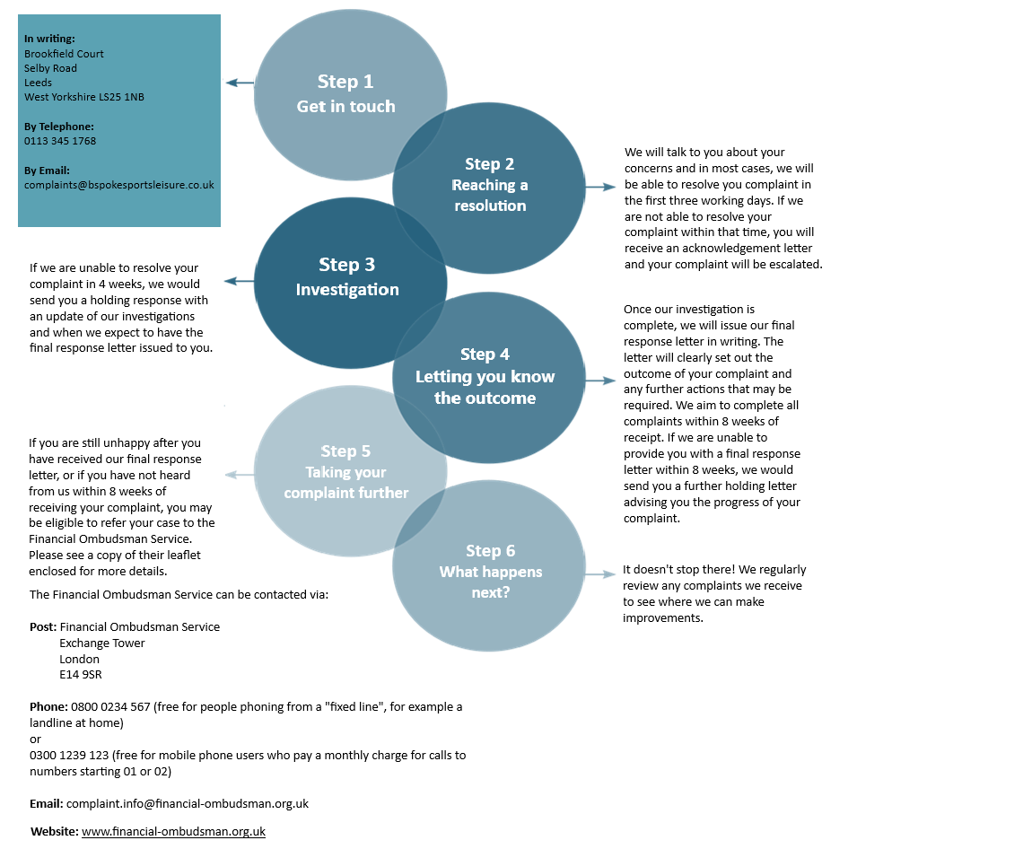

This complaint procedure does not affect your right to take legal action.

Bspoke Sports & Leisure is a trading name of Bspoke Commercial Ltd. Bspoke Commercial Limited is authorised and regulated by the Financial Conduct Authority. Firm Reference No. 709456. Registered in England and Wales Company Number. 09284678. Registered Office: Brookfield Court, Selby Rd, Leeds LS25 1NB.

