
Making a complaint.

At Bspoke Property Owners, we care about our customers and believe in building long-term relationships by providing quality products combined with a high standard of service. If you have cause for complaint, either in relation to your policy or any aspect regarding the standard of our service, please see the contacts outlined below.

As you have arranged your policy with Bspoke Property Owners through a Broker or Administrator, you should firstly direct your complaint to the Broker or Administrator.

Useful complaint contacts are provided below:

Reason for complaint | Contact | Contact Details
Sales or Service  Related | Complaints Department  Bspoke Commercial  Limited | Bspoke Property Owners  Brookfield Court  Selby Road  Leeds  West Yorkshire  LS25 1NB  complaints@bspokecommercial.co.uk  0113 345 1768
Claims (other than  Legal Expenses or  Equipment Breakdown claims  noted below) | Complaints Department  Sedgwick International  UK | Oakleigh House  14-16 Park Place  Cardiff  CF10 3DQ  bspokecommercialclaims1@uk.sedgwick.com  0345 850 0597
Legal Expenses Claims | Complaints Department  Arc Legal Assistance  Limited | PO Box 8921  Colchester  CO4 5NE  customerservice@arclegal.co.uk  01206 615000
Equipment  Breakdown  Claims | Complaints Department  HSB Engineering Insurance | Chancery Place  50 Brown Street  Manchester  M2 2JT  claims@hsbeil.com  0330 100 3443

Bspoke Property Owners Complaints Process

Making a complaint can be stressful, that’s why we want to make the whole process as easy as possible for you.
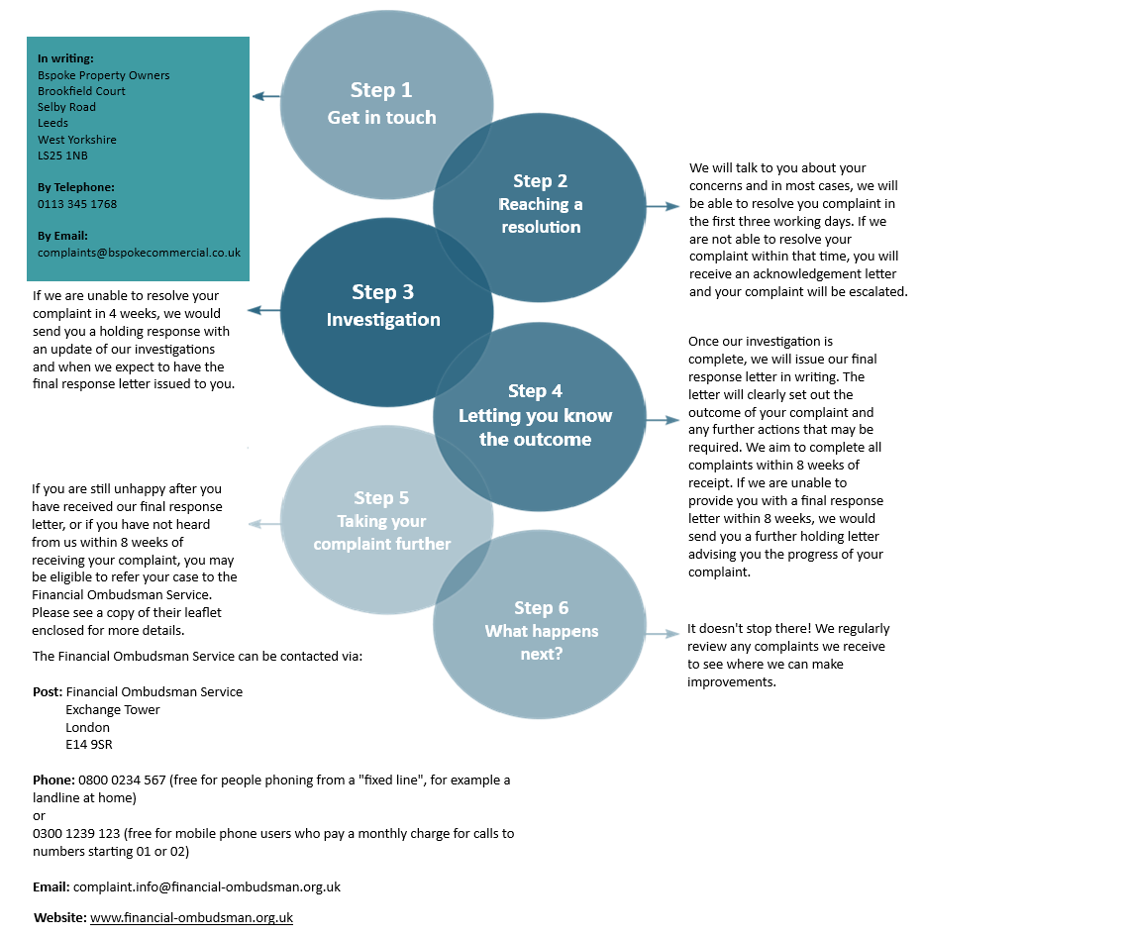

This complaint procedure does not affect your right to take legal action.

Bspoke Property Owners is a trading name of Bspoke Commercial Ltd. Bpoke Commercial Limited is authorised and regulated by the Financial Conduct Authority. Firm Reference No. 709456. Registered in England and Wales Company Number. 09284678. Registered Office: Brookfield Court, Selby Rd, Leeds LS25 1NB.

