
Making a complaint.

At Bspoke Private Clients, we care about our customers and believe in building long-term relationships by providing quality products combined with a high standard of service. If you have any questions or concerns about your insurance or the handling of a claim, please see the contacts outlined below.

Useful contacts:

Premier Home Insurance policies

Enquires/complaints | Contact Details
Policy Enquiries or Service/Product Related Complaints | Bspoke Private Clients  Brookfield Court, Selby Road, Leeds LS25 1NB  Tel: 0333 400 0473  Email: enquiries@bspokeprivateclients.co.uk
Claims Enquiries | The Claims Team  2 West Parade, Croft Myl, Halifax  HX1 2EQ  Tel: 0161 529 1400  Email: personal.lines.claims@penunderwriting.com
All Other Complaints | Complaints Officer,  Spectrum Building, 55 Blythswood Street, Glasgow  G2 7AT  Tel: 0141 285 3539  Email: pencomplaints@penunderwriting.com  Details of Pen Underwriting complaints procedures are available at:  http://www.penunderwriting.co.uk/Pages/Complaints.aspx

Gold and Platinum Home Insurance policies

If you have a complaint regarding the sale or service of your Gold or Platinum Home Insurance policy, please contact your insurance Intermediary or Administrator. Alternatively, you can contact us using the details below.

Complaints | Contact Details
For complaints relating to Sections 1 to 3, Buildings, Contents or Liabilities. | Bspoke Private Clients  Brookfield Court  Selby Road  Leeds  LS25 1NB  Tel: 0333 400 0473  Email: enquiries@bspokeprivateclients.co.uk
For complaints about claims relating to Section 4 Home Emergency and Section 5 Family Legal Protection. | Arc Legal Assistance Limited  PO Box 8921  Colchester  CO4 5NE  Tel: 01206 615000  Email: customerservice@arclegal.co.uk

Bspoke Private Clients Complaints Process

Making a complaint can be stressful, that’s why we want to make the whole process as easy as possible for you.

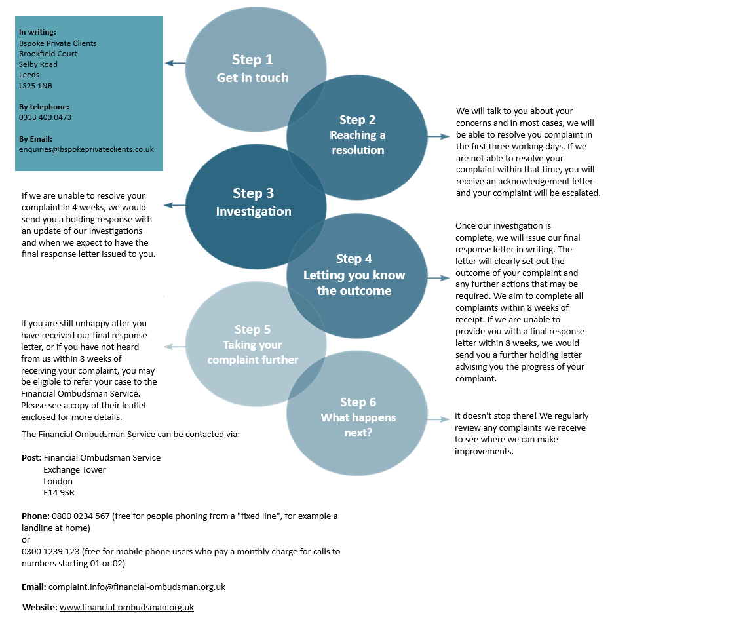
This complaint procedure does not affect your right to take legal action.

Bspoke Private Clients is a trading name of Bspoke Commercial Limited. Bspoke Commercial is registered in England and Wales Company Number. 09284678. Registered Office: Brookfield Court, Selby Rd, Leeds LS25 1NB. Bspoke Commercial is authorised and regulated by the Financial Conduct Authority. Firm Reference No. 709456.

